1. Create the following directories and files following the hierarchy structure

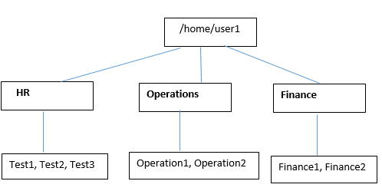

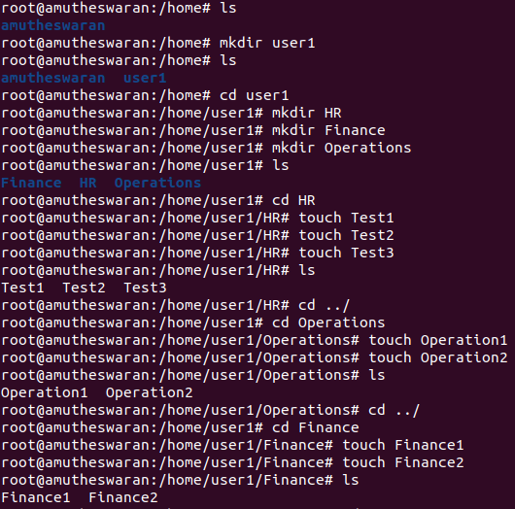

2. Copy the test1 file from HR directories to Finance directories

3. Create a directory called Account under the Finance directory

4. Create files Account1.csv, Account2.csv under Account directory

a. Write below content (Account1.csv)

b. Write below content (Account2.csv)

5. Copy all the entire structure of Finance directory to Operation directory

6. Rename Account2.csv to Employee.csv

7. Move the file Test1 to Operations

8. Move all the files from HR directory Operation directory

9. Delete all the files which is present in HR directory

10. Remove the entire Finance directory from Operation directory

11. Display the content of Account2.csv

12. List all the files which is present in Finance directory except directory.

13. Display all the users connected to Ubuntu

14. Search for all the files starting with T from the home directory

15. Create hidden file called “Test” under Finance directory

16. Filters

a. Perform following operations with Account2.csv

i. Display the Name in sorted order

ii. Display the no of employees staying in India



iii. Display the content in upper case

iv. Display all the Name starting with “B”



b. Perform following operations with Account1.csv

i. Display two columns (ExpensesDate,Amount)

ii. Display the details of 10-Apr-2018



17. Display all the process running in the Ubuntu system

18. Create two files under HR directory

a. Sample1.txt

b. Sample2.txt

19. Permissions

a. Give read only permission for all the files which is in Operation directory

b. Remove all the permission for the files which is in Finance directory

c. Give write and execute for all the files which is in HR directory

d. Change the owner of Sample1.txt to Test2 user

e. Change the group of Sample2.txt to Test1 user

20. Create users

a. Test1

b. Test2

21. Display the command to view all the users which is existing in the system

22. Create a compressed file for the Finance directory

